SMC Expert Article – Sustainability

Deep customer partnership drives optimal automation solutions

By Dan Ives, Senior Project Engineer, European Technical Centre

We work closely with our customers to develop solutions based on real-life projects that, for example, align directly with their goals. This approach provides SMC with a solid foundation for the development of optimal solutions, one that we ultimately roll out to benefit the wider industry. A case in point is the new Air Management System, which not only helps to reduce compressed air consumption, by up to 62%, but also cuts carbon emissions due to less air requirement in times of low or no demand.

A global blue-chip company collaborates deeply with SMC to assist with both its Sustainable Development Goals (SDGs) and Digital Transformation goals. The customer was looking for a solution which could provide high-resolution data to assist in monitoring the air use (pressure, flow and temperature) of its machines, while also providing economic control of the air supply. The solution had to be suitable for retrofitting onto existing machinery and to be supplied on new machines. Further requirements included easy access to data and simple commissioning. Based on these prerequisites, our team of engineers set about developing the Air Management System.

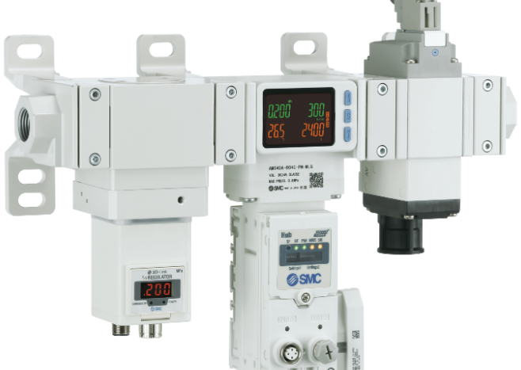
SMC´s Air Management System - Level up your compressed air management

Driving sustainability
Typical production lines at the customer consist of around 10 different machine types handling a minimum of 180 bottles per minute. Each machine performs various operations using compressed air, including air blowing and vacuum holding, which result in high air use and, therefore, high energy costs. Due to the wide differences between each machine, the concept for our Air Management System centres on universal machine conditions such as stop, run, wait and error. Considered a universal standard, PackML provides the definition for these conditions.

To provide an example of how the Air Management System functions, consider a bottle unscrambling machine is idle because of an issue with the bottle labelling machine down the line. Previously, the unscrambling machine was not intelligent and would continue consuming air. However, the Air Management System uses the machine’s ‘wait’ signal as permission to do something positive. For instance, if the wait signal exceeds a customer-determined duration, the Air Management System regulates to a lower, secondary pressure, such as 4 bar instead of the 7 bar primary pressure. As a result, the flow rate reduces, typically by more than half, providing a dramatic reduction in air consumption energy and CO₂ emissions. SMC’s Air Management System also has an optional valve for full isolation mode (compressed air isolation). Upon exceeding a secondary customer-determined duration, the same machine can completely stop any unnecessary use of compressed air, further reducing its energy requirements.

Asset-level digitalisation
We made the Air Management System extremely flexible regarding connection options: it is possible to deploy either a wired connection or, using our proprietary wireless connectivity, you can utilise one wired connection to a base unit that collates data from up to 10 remote devices. You can also choose to connect it to your fieldbus network, or simply use the device’s integrated OPC UA server interface, negating the impact and complexity of communicating with machines featuring different fieldbus protocols.

The system is entirely ‘dark factory ready’, providing you with the opportunity for decentralised control and monitoring. Aside from energy savings, data analysis forms the basis for defining efficiency gains and preventative maintenance activities.

Our Air Management System facilitates the collection of high-resolution data (10Hz), allowing you to trend the pressure, flow and temperature of each machine equipped with the product. This data enables the customer to measure and monitor their assets and make informed decisions on when to maintain their machines. Users can also pass the data into other services such as computerised maintenance management systems (CMMS) or AI machine learning packages.

Rapid ROI
With the Air Management System, the savings are typically small per intervention. However, over the course of a machine’s annual duty cycle, multiplied by several machines and production lines, our customer achieved an exceptionally fast return on investment (ROI).

In all applications involving the Air Management System, there is no need to access your machine’s PLC. Instead, the near plug & play nature of system works with each machine individually and universally, requiring just one 24 VDC signal. Digital integration is also easy as one Air Management System wireless hub allows you to connect to 10 remote units, within a 100m radius, providing a more economical cost and reduced integration outlay.

As a final point, the Air Management System is not just for large OEMs. The system’s affordable price point and rapid ROI make it suitable for companies of all sizes, including those without advanced digital architecture.

END

