SMC Customer case – SubCtech
Precise Measurement Technology that is also great for the Climate
By Klaus Semik, Sales Engineer IFC, SMC Germany

Unique treasure trove of data after world sailing tour
Around the world in 80 days: that’s what sailor Boris Herrmann achieved at the beginning of 2021 in the toughest ocean regatta, the Vendée Globe. Defying all odds to reach the finish line is a challenge for human and material – right down to the smallest cells and components. Precise and robust technology from marine technology supplier SubCtech and pneumatics specialist SMC provided unique environmental benefits: During the round-the-world voyage of Herrmann's "Seaexplorer – Yacht Club de Monaco", an automated laboratory collected, among other things valuable CO₂data over hitherto little-travelled sea routes. And another realisation: The success lies in the component
All kinds of climate, wind and weather conditions, more than 45,000 kilometres of Atlantic and Southern Ocean lying in wait – and all this non-stop and completely alone in an ocean-going sailing yacht: these were the starting conditions for the world's toughest regatta, the Vendée Globe, at the end of 2020. The event also captivated thanks to German Boris Herrmann, who reached the start and finish port in Les Sables-d'Olonne, France, in January after exactly 80 days, 14 hours, 59 minutes and 45 seconds. This put him almost on a par with the hero in Jules Verne's novel. While the time zones almost prevented Herrmann from success, in the end it was a collision with a fishing trawler that prevented him from a podium finish. Nevertheless, alongside sailing fans, researchers are also delighted: the fifth-place winner transmitted valuable CO₂data – recorded by the OceanPack™ RACE system from the Kiel-based marine technology company SubCtech GmbH, which integrates components from the automation and pneumatics specialist SMC from Egelsbach near Frankfurt am Main.
Treasure trove of CO₂ data from the world's oceans
The automated laboratory permanently measures the water’s temperature, conductivity, salinity and CO₂-concentration. It sends these via satellite to a database, which is evaluated by the Max Planck Institute for Meteorology in Hamburg and the Geomar Helmholtz Centre for Ocean Research in Kiel, among others.
CO₂measurement data is particularly difficult to obtain: data has been captured from the marine region and major trade routes, but huge white spots remain, especially on the southern oceans. According to Herrmann, the measuring system is therefore of "great benefit" to science¹. Moreover, it didn’t impair him in any way during journey, thanks to its automated operation. Incidentally, to ensure that his sail journey was CO₂-neutral, his yacht is supplied with energy via photovoltaics and hydro generators (turbines at the stern) for bad weather phases.
Marine specialists meet pneumatics professionals
For the first time, it was possible "to permanently collect data over the entire journey – and the entire way around the world," confirms SubCtech product manager Jana Fahning. Founded by CEO Stefan Marx, the company supplies the measurement laboratory called OceanPack™ RACE. What makes it so unique is that, unlike large and heavy systems for research vessels, the instruments in this device from SubCtech are optimised for racing yachts. Carbon fibre allowed the weight to be almost halved, and the system has also been made more compact and robust². Moreover, the optimised technology created a significant reduction in power consumption. In short, all essential components for quality measurements were realised with the OceanPack™ RACE system.
SubCtech kept the scientific requirements in mind above all. All sensors meet the high demands placed on by research – and all components also meet the requirements for use in adverse environments. And this is indispensable on the high seas, as large machines and the smallest components are exposed to enormous vibrations and have to withstand extreme temperature fluctuations. External temperatures ranged from -5 to 35° Celsius. Even small, elementary components – such as those from SMC for the CO₂analyser used to calibrate analysis paths – meet the high demands for flexibility, energy efficiency and durability. The company is proud to have supplied reliable components for such an important research project, and that they withstood the extremely adverse conditions on the high seas.
Success (also) lies in the smallest component
This is because high-tech solutions can not only be found on the immediately visible surface of the high-performance sailing yacht, but also in the smallest components of the analysis technology in the OceanPack™ RACE: SMC components for CO₂measurement range from solenoid valves (LVM205RY-6A-6-Q) to line filters for compressed air/vacuum applications (ZFC53-X15) and throttle check valves (AS1211F-M5-04A) to connection solutions (Schott plug-in connector KQ2D, S-coupler KK2S/P-04L). These are based on standard components that are, however, generally used successfully in high-performance industries such as automotive or medical technology.
In the case of the CO₂analyser in the OceanPack™ RACE on the "Seaexplorer – Yacht Club de Monaco", the basic principle concerns a semi-permeable membrane, which forms a barrier between water and the gaseous analysis circuit. CO₂ and other gases can pass through this membrane, but water cannot. As the CO₂content cannot be measured directly in water, is measured behind the membrane. To ensure that particularly accurate data is obtained, the sensor is calibrated daily. While the SMC throttle controls the gas flow during calibration (approx. 0.5-1.0 l/min), the purpose of the filter is to protect the measuring cell against impurities emanating from the gas. While other models have to be unscrewed to change the filter, this SMC model’s filter insert can simply be changed using a bayonet lock. Pressure regulators also reduce the high gas cylinder pressure of approx. 200/250 bar to a working pressure of 0.5 bar.
Ecological measurement with economic solutions
All components must also be highly efficient in terms of functionality, housing design and energy consumption. For example, the valves (six-piece assembly with self-made manifold or base plate) for switching ambient air and gas. While a standard valve consumes about 2.5 watts, this energy-saving valve requires only 0.6 watts in hold mode. A tiny detail, but a big contribution to making the sailing yacht as energy efficient as possible. It has proven that it can function even under difficult conditions such as changing temperatures and high impact loads.
For one thing, the solutions offered by SMC, a supplier of pneumatic and electrical automation systems that has been active on the German market since 1978, show that research and development work is successfully reflected in even the smallest components. For another, they represent the wide range of extremely reliable components for a wide range of pneumatic and automation applications.
A race for and around the planet
Even before crossing the finish line, Herrmann confirmed that data quality and accuracy had been accepted by international databases with the highest quality flags. Initial results additionally show that salinity in the world's oceans fluctuates³: it is low at the equator, even in the Atlantic Ocean, which normally has the highest salinity. The reason for this is the convergence zone there, where a lot of rain dilutes the surface water. Incidentally, another yacht, that of Frenchman Fabrice Amedeo, was equipped with OceanPack™ RACE – and an additional microplastic sampling unit – but didn’t reach the finish line. After the race is before the race, says the successful Herrmann, looking ahead to the next Vendée Globe and Ocean Race, which starts in September 2022. And next time, he will again be equipped with "Made in Germany" measuring technology. Herrmann certainly hopes that the commitment to the project will strengthen the effort to limit global warming⁴. "This is a race we can and must win."

Sources
1 “Boris Herrmann Talks About OceanPack RACE”, SubCtech. https://subctech.com/boris-herrmann-seexplorer-yacht-club-de-monaco-talks-about-oceanpack-race-during-vendee-globe/
2 “Vendee Globe – A Race For Science”, SubCtech. https://subctech.com/the-vendee-globe-a-race-for-science/
3 "Boris Herrmann equipped with Kiel technology at Vendée Globe", Schleswig-Holsteinischer Zeitungsverlag. https://www.shz.de/regionales/schleswig-holstein/Zustand-der-Meere-Boris-Herrmann-hatte-bei-Vandee-Globe-Kieler-Technologie-dabei-id31310592.html
4 "Deep-sea sailor Boris Herrmann: Climate protection on board", Deutsche Welle. https://www.dw.com/de/hochsee-segler-boris-herrmann-klimaschutz-mit-an-bord/a-56360756

Images
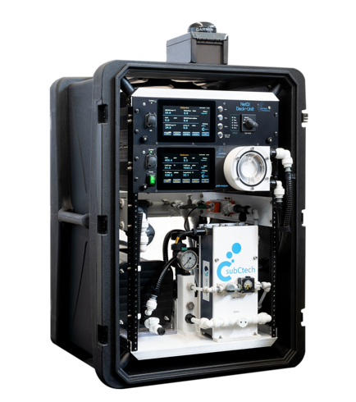
Figure 1: OceanPack™ CUBE, rugged and user-friendly instrument for scientific environmental observations in a compact 19-inch format. (Source: SubCtech)

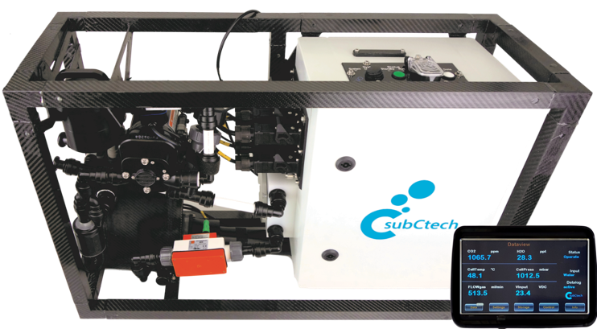
Figure 2: OceanPack™ RACE with external control panel for innovative climate data collection at the interface between ocean and atmosphere. (Source: SubCtech)

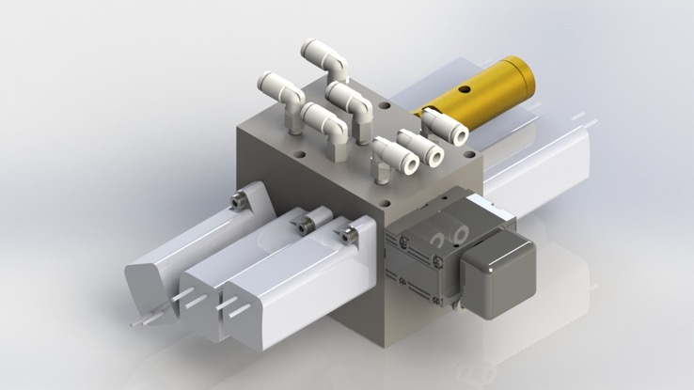
Figure 3: Valve terminal/pneumatic module for switching between different measuring phases and for automatic calibration of the CO₂ sensor. (Source: SubCtech)

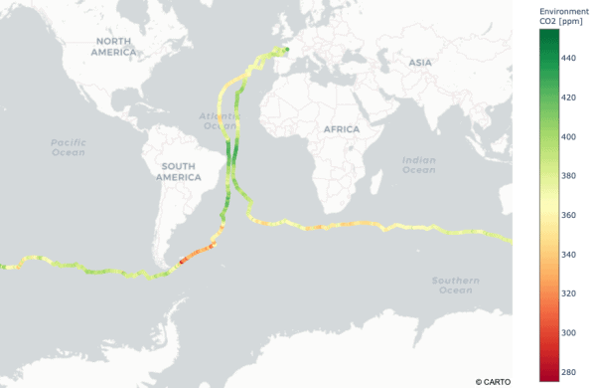
Figure 4: CO₂ data from the 2020/2021 Vendeé Globe recorded by OceanPack™ RACE on the Boris Herrmann’s "Seaexplorer – Yacht Club de Monaco". (Source: Peter Landschützer, Max Planck Institute for Meteorology, Hamburg)

