Eagle eyes with a soft touch: Full automation versatility for RoboInspect from Roboworker

By Raimund Bauer, Sales Engineer at SMC Germany

Perfectly matched pneumatic and electric solutions for machines that inspect sintered parts and other workpieces

Medical implants, indexable inserts, drills, end mills, gears – the variety of metallic and ceramic components used in different industries is virtually endless. If large quantities are required, many of these components can be produced using sintering. They are often first pressed from powder in a sintering process and then heated. Some of the finished workpieces have to be inspected, labelled and packaged. This is best done automatically, non-stop. To ensure efficient quality assurance, Roboworker has developed RoboInspect, a machine for micrometre-accurate, all-round inspection of workpieces with high requirements. Both there and in other systems of the Roboworker product range, a wide range of electrical and pneumatic automation components from SMC are used.

Large quantity production of metal and ceramic parts with complex geometries often using the sintering process. In this process, powder is pressed into a defined shape and compacted in its new structure with an appropriate heat treatment – sintering – as well as being hardened. Depending on the application, additional coatings can be applied in further process steps. The finished workpieces are used in a wide variety of industries, and end consumers also use these components in the do-it-yourself sector, for example. To ensure that the workpieces arrive on the shelves in the right quality with optimal packaging, they must be put through their paces in the final production step – only perfectly coated and formed parts may go to market. After all, the automotive industry, as well as aerospace, battery and medical technologies, all have strict performance requirements for their components. To carry out fully automatic all-round inspection of the workpieces, Roboworker has equipped the RoboInspect (RIS) with a wide range of 3D+ functionalities for checking the dimensional accuracy and quality of a workpiece. The system can also be optionally expanded with modules for laser marking or packaging the workpieces. A comprehensive pneumatic and electrical automation package from SMC, featuring a maintenance unit, valve terminals, electric and pneumatic drives as well as pressure boosters, ionizers and many other components, ensures that the workpieces are handled gently, precisely and quickly during inspection, labelling and packaging.

For more than 30 years, Roboworker has been known for its extensive expertise in the areas of automation and inspection. With high-performance linear robots, grippers, sensors and camera technologies, the mechanical engineering experts based in Weingarten near Ravensburg create flexibly deployable and modular high-tech automation systems for manufacturing precision parts. This also includes optimal, automatic inspection machines for sintered parts and workpieces made from a wide variety of starting materials, such as carbide, iron powder or ceramics. Demanding industries such as metal processing, automotive or battery and medical technology use Roboworker's highly efficient systems.

Inspection, labelling and packaging of sintered parts
Anyone who sinters is using one of the oldest known manufacturing processes. The principle was probably first used in the moulding and firing of porcelain. The idea behind it is simple: it is not practical to make a porcelain block and then cut or chisel the desired shape out of it again. Therefore, it was easier to mould the starting material in the "raw" state and then fix it with heat and glaze. Today, many small metal parts go through a similar process. "The advantage of sintering is that it enables small workpieces with difficult shapes to be produced in large quantities," says Toralf Schramm, Inspection and Packaging Systems Manager at Roboworker. "A sintered indexable insert, for example, typically just needs a coating and it's done." The starting materials for the process are mixtures of different powdered metals, which form high strength units in the finished product. To do this, they are first pressed into shape at pressures of 16 to 400 tonnes, depending on the material and application. Due to the compaction of the mixed powder during the pressing process, these raw moulds hold together until they are further compacted by heat treatment during sintering. This is what gives the workpieces their required strength in the first place.

No defective workpiece may leave the hall. Therefore, the finished product is thoroughly tested once again before packaging. This ensures optimum quality. Toralf Schramm: "The parts’ geometry is particularly important. Applications in medical technology or the automotive industry have enormously low tolerances, so every product has to be perfect." These tolerances are in ranges that are no longer visible to the human eye. The RoboInspect therefore checks the workpiece’s dimensional accuracy and quality using high-precision technologies that operate in the micrometre range. This allows the smallest defects such as local edge chipping as well as shape and coating defects to be reliably identified and traced back through detailed documentation.

The coated workpieces are fed into the system on pallet stacks. To minimise false rejections, an ionizer first reduces any static charge present. This frees the workpieces from adhering dust. The released dust is extracted by an SMC series ZH volume booster to prevent it from settling inside the machine or from clogging filters. Precise robots place the workpieces individually on an inspection tray, where high performance, extremely sensitive cameras inspect them from all sides. Various characteristics are checked within seconds: Cutting edge damage to within 5 microns, dimensional accuracy to within 0.01 millimetres, and surface defects to within 0.05 millimetres, depending on the quality of the surface. Afterwards, the workpieces can be labelled with a laser if necessary before being placed back into the pallets. In addition, they can optionally be directly end-packed in a packaging module, labelled and made ready for shipment to the user. "The RoboInspect is a revolutionary machine. It can be flexibly expanded and works with high precision in the process," emphasises Toralf Schramm. "Grippers and cameras must be able to map complex movement patterns very accurately and always be in the right position."

Automation package adapted to all requirements
To ensure smooth inspection of the sintered parts, the demanding handling processes within the RoboInspect must be reliable and precise. "Another challenge is the different compressed air requirements of different areas in our machines," explains Ralf Trotzki, Design Manager for Inspection and Packaging Systems at Roboworker. "For example, to release workpieces held by a magnetic gripper on a deposit plate, a higher pressure is needed to achieve the required release force than the system's set pressure. A pressure booster therefore increases the pressure for the release cylinder, and only when it is needed. This can save a lot of compressed air." All used components must also be extremely space-saving and reliable – the demands of the industry are very high and the space available in factory halls is limited. The suitable automation technology at Roboworker comes almost exclusively from SMC.
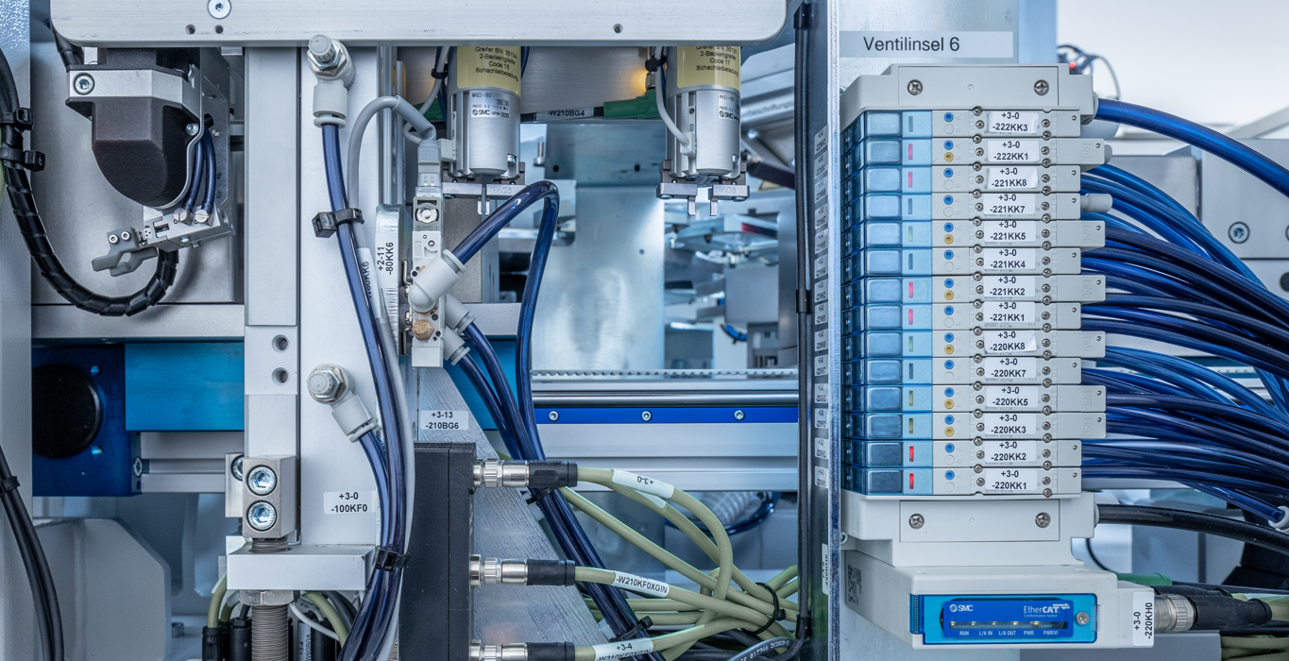

The SY series manifold valves from SMC provide the pneumatic heart of RoboInspect and provide the right pressure for every application with their modular design.

Timo Schlauch, Team Leader at SMC: "Roboworker's experts know they can rely on our solutions. After all, they've been using SMC technologies in their machines for 24 years." The heart of the pneumatic automation in RoboInspect is the SY series valve terminal. It has a modular design, which enables a wide variety of actuators to be supplied with different required pressures. In addition, the valve terminals are equipped with EtherCat bus modules that network them with the higher-level machine controller and with each other. "This saves a lot of design and installation effort compared to individual cabling, and the complete system is less susceptible to faults. It also becomes much easier and more cost-efficient to maintain and service the plant in operation," says Timo Schlauch. "In such complex plants, the individual processes must be optimally coordinated with each other – also in the control system." Proportional valves from SMC’s ITV series are connected upstream of the valve terminal for certain processes and precisely control the force of the pneumatic grippers to avoid damaging the workpieces, during pickup and transfer for example. The compact design of the SY manifold valve with its bus control allows decentralised mounting directly in Roboworker’s modular assemblies and also allows them to be networked with each other and with the control system.
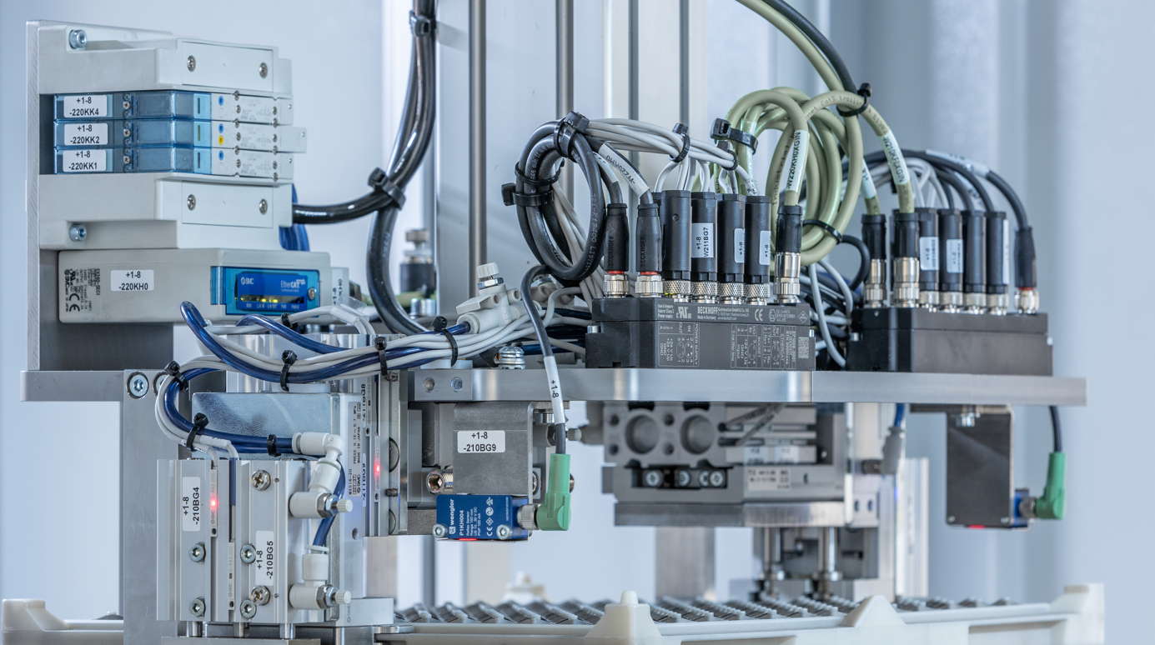

Optimal control: SMC's proportional valves in the ITV series precisely control the force of pneumatic grippers, to avoid any damage to the workpieces, for example during pick-up and transfer.

Many years of experience and a trusting partnership
All inspection machines delivered by Roboworker since 2010 are still running today – this is also thanks to the perfectly matched automation package from SMC. "The long-standing partnership with SMC enables us to always find and use the right technologies for our machines with confidence and total trust," stresses Toralf Schramm. In the future, the mechanical engineering experts will also be able to benefit from newly developed and even more compact valve terminals that are integrated directly into the robot arms. All components have long and reliable working lives in production worldwide – and if a replacement is needed, SMC's service and support network sends it quickly to any location.

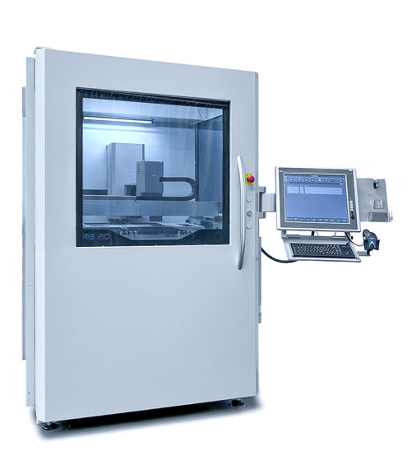
All available photos

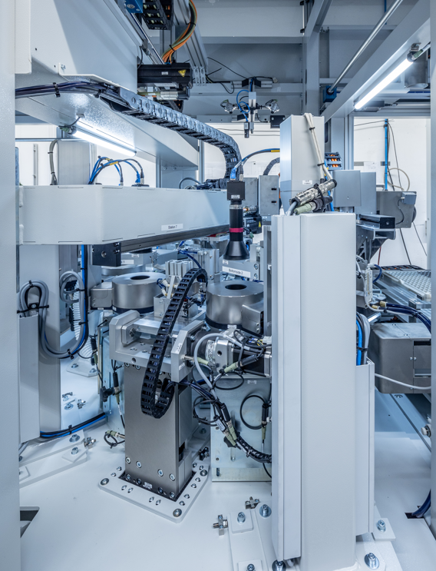
[Fig. 1] Revolutionary testing machine: Roboworker's expandable modular RoboInspect system inspects workpieces for damage in the micrometre range.

[Fig. 2] A very precise eye on workpieces: pneumatic handling solutions from SMC supply the inspection station’s high-precision cameras.

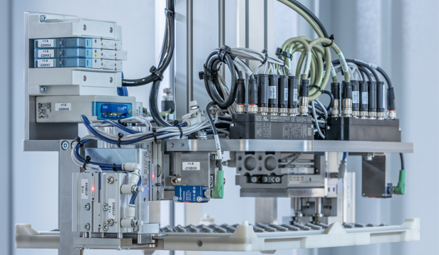
modular

[Fig. 3] Optimal control: SMC's proportional valves in the ITV series precisely control the force of pneumatic grippers, to avoid any damage to the workpieces, for example during pick-up and transfer.
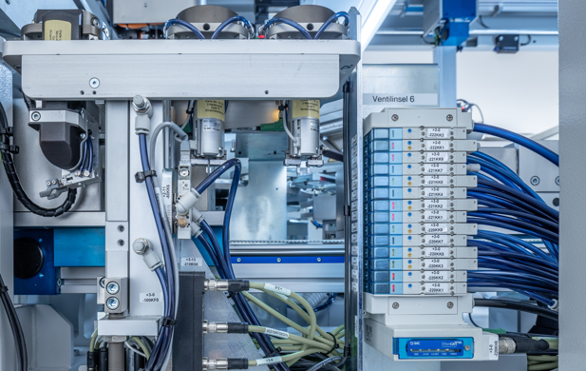

[Fig. 4] The SY series manifold valves from SMC provide the pneumatic heart of RoboInspect and provide the right pressure for every application with their modular design.

